Session 2025-2026(EVEN)

Vision:Dream of where you want. | Mission: Means to achieve Vision

Program Educational Objectives of the program (PEO): (broad statements that describe the professional and career accomplishments)
PEO1 | Preparation | P: Preparation | Pep-CL abbreviation  pronounce as Pep-si-lL easy to recall
PEO2 | Core Competence | E: Environment (Learning Environment)
PEO3 | Breadth | P: Professionalism
PEO4 | Professionalism | C: Core Competence
PEO5 | Learning Environment | L: Breadth (Learning in diverse areas)

Program Outcomes (PO): (statements that describe what a student should be able to do and know by the end of a program)
Keywords of POs:
Engineering knowledge,Problem analysis, Design/development of solutions,Conduct Investigations of Complex Problems, Engineering Tool Usage, The Engineer and The World,Ethics, Individual and Collaborative Team work,Communication, Project Management and Finance, Life-Long Learning

PSO Keywords: Cutting edge technologies, Research

“I am an engineer, and I know how to apply engineering knowledge to investigate, analyse and design solutions to complex problems using tools for entire world following all ethics in a collaborative way with proper management skills throughout my life.” to contribute to the development of cutting-edge technologies and Research.

Integrity: I will adhere to the Laboratory Code of Conduct and ethics in its entirety.

Anushka Yede
6/03/2026
Name and Signature of Student and Date
(Signature and Date in Handwritten)

Session | 2024-25 (EVEN) |  | Course Name | Mobile and Web Application for IOT Lab
Semester | 6 |  | Course Code | 23IOT1624
Roll No | 01 |  | Name of Student | Anushka Yede
Practical Number |  | 04
Course Outcome |  | CO1 To understand the different flavors of mobile operating system and their specific features.  CO2 Apply Android applications using various UI controls and layouts.  CO3 Analyze applications capable of data handling and communication with native components.  CO4 Create and develop applications that support multiple devices and configurations.
Aim |  | Understand Android Studio environment and project structure. Tasks: Create Android project, analyse the AndroidManifest file, Gradle build files, SDK versions, and permissions.
Problem Definition |  | Problem Title: Android Studio Project Setup and Configuration Analysis  You are provided with a freshly installed Android Studio environment. Perform the following tasks using the given IDE:  1. Create a new Android project named MyFirstApp with Java, package com.darshil.myfirstapp, minSdk = 24, targetSdk = 34.  2. Navigate the full project directory and note the role of each folder and configuration file.  3. Open AndroidManifest.xml and add INTERNET (normal) and ACCESS_FINE_LOCATION (dangerous) permissions. Register MainActivity with MAIN/LAUNCHER intent-filter.  4. Open app/build.gradle. Record compileSdkVersion, minSdkVersion, targetSdkVersion, and the list of dependencies declared.  5. Write runtime permission request code in MainActivity.java for ACCESS_FINE_LOCATION. Verify that the system permission dialog appears when the app runs on the emulator (Pixel 6, API 34).
Theory  (100 words) |  | 1. The Map: Organizing the Data  Think of a Map as a digital attendance sheet. In a regular list, you just have a row of names. In a map, you have Key-Value pairs.  - Key: The unique identifier (Student Name).  - Value: The data attached to it (Marks).  Using a map makes it incredibly fast to look up exactly how many marks "Ayush" got without having to scan through every single student in the list.  2. Iteration with forEach  The forEach function is like a teacher walking down the rows of a classroom and performing the same action for every student. Instead of writing a complex loop with counters, forEach lets you say: "For every person in this map, do this specific task." It’s cleaner, harder to break, and easier for others to read.  3. The Filter-Map-Transform Pipeline  This is where Kotlin’s functional power shines. Instead of changing the original data (which can lead to mistakes), we treat it like a pipeline:  - filter: This acts as a security guard. It checks a condition (marks > 60) and only lets the passing students through to the next stage.  - mapValues: This is a specialized transformation. It keeps the "Key" (the student's name) the same but updates the "Value" (adding the grace marks).  4. Higher-Order Functions: The "Smart" Helpers  A Higher-Order Function is simply a function that is "smart" enough to accept another function as a tool.  - Human Analogy: Imagine a generic "Machine." If you give it a "Juicing" instruction, it makes juice. If you give it a "Grinding" instruction, it makes flour.  - In our code, analyzeGrade is the machine, and the gradingLogic is the instruction manual we pass into it. This makes your code modular; if you want to change the grading system next year, you only change the "manual" (the lambda), not the "machine" (the function).
Procedure and Execution  (100 Words) |  | Step for Implementation:  1. The Setup (The Registry)  You start by creating a Map. In human terms, this is just a digital ledger where you link a student's name (the unique key) to their score (the value).  2. The Review (The Roll Call)  Use forEach to cycle through the list. It’s the programmatic version of a teacher reading the class list out loud to make sure everyone is accounted for.  3. The Cut-off (Filtering)  We apply a .filter to separate those who reached the 60-mark threshold from those who didn't. This ensures the rest of our logic only applies to the "passing" group.  4. The Boost (Transformation)  Using .mapValues, we perform a "bulk update." We aren't changing the names, just sliding an extra 5 marks onto the scores of everyone who made it through the filter.  5. The Logic (Higher-Order Function)  This is the "brain" of the operation. We create a function that doesn't just process numbers but accepts a grading rule (a lambda) as an input.  6. The Result (Grading)  Finally, we pass our updated marks through that "brain" to convert numbers into letters (A, B, or C) and print the final report card.
// ─── AndroidManifest.xml ───────────────────────────────────
<?xml version="1.0" encoding="utf-8"?>
<manifest xmlns:android="http://schemas.android.com/apk/res/android"
package="com.vedant.myfirstapp">

<uses-permission android:name="android.permission.INTERNET"/>
<uses-permission
android:name="android.permission.ACCESS_FINE_LOCATION"/>

<application
android:allowBackup="true"
android:icon="@mipmap/ic_launcher"
android:label="@string/app_name"
android:roundIcon="@mipmap/ic_launcher_round"
android:supportsRtl="true"
android:theme="@style/Theme.MyFirstApp">

<activity
android:name=".MainActivity"
android:exported="true">
<intent-filter>
<action android:name="android.intent.action.MAIN"/>
<category android:name="android.intent.category.LAUNCHER"/>
</intent-filter>
</activity>
</application>
</manifest>

// ─── app/build.gradle ───────────────────────────────────────
plugins { id "com.android.application" }
android {
compileSdk 34
defaultConfig {
applicationId "com.vedant.myfirstapp"
minSdk 24
targetSdk 34
versionCode 1
versionName "1.0"
}
buildTypes { release { minifyEnabled false } }
}
dependencies {
implementation "androidx.appcompat:appcompat:1.7.0"
implementation "com.google.android.material:material:1.12.0"
implementation "androidx.constraintlayout:constraintlayout:2.1.4"
}

// ─── MainActivity.java ──────────────────────────────────────
package com.vedant.myfirstapp;
import android.Manifest;
import android.content.pm.PackageManager;
import android.os.Bundle; import android.widget.Toast;
import androidx.appcompat.app.AppCompatActivity;
import androidx.core.app.ActivityCompat;
import androidx.core.content.ContextCompat;

public class MainActivity extends AppCompatActivity {
private static final int LOC_CODE = 1001;
@Override
protected void onCreate(Bundle savedInstanceState) {
super.onCreate(savedInstanceState);
setContentView(R.layout.activity_main);
checkLocationPermission();
}
private void checkLocationPermission() {
if (ContextCompat.checkSelfPermission(this,
Manifest.permission.ACCESS_FINE_LOCATION)
!= PackageManager.PERMISSION_GRANTED) {
ActivityCompat.requestPermissions(this,
new String[]{Manifest.permission.ACCESS_FINE_LOCATION},
LOC_CODE);
} else {
Toast.makeText(this,
"Location Permission Already Granted",
Toast.LENGTH_SHORT).show();
}
}
@Override
public void onRequestPermissionsResult(int requestCode,
String[] permissions, int[] grantResults) {
super.onRequestPermissionsResult(
requestCode, permissions, grantResults);
if (requestCode == LOC_CODE) {
boolean granted = grantResults.length > 0 &&
grantResults[0] == PackageManager.PERMISSION_GRANTED;
String msg = granted ? "Permission Granted !" : "Permission Denied !";
Toast.makeText(this, msg, Toast.LENGTH_SHORT).show();
}
}
}
Output:
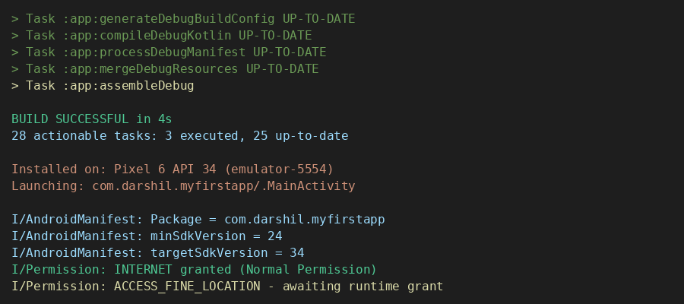

Output Analysis |  | - Project Structure Clarity: Exploring the project tree in Android Studio made it easy to identify where each file belongs. The separation between source code, layouts, and config files follows a strict convention that keeps large projects manageable.  - Manifest as a Contract: The AndroidManifest.xml acts like a contract between the app and the OS. Without registering MainActivity with the MAIN/LAUNCHER intent-filter, the system launcher would not know which screen to open on app start.  - SDK Version Impact: Setting minSdk = 24 allows the app to run on roughly 94% of active Android devices. Using compileSdk = 34 ensures the code is compiled against the newest APIs, enabling access to the latest Android features during development.  - Runtime Permission Dialog: When the app launched on the emulator, the system dialog appeared requesting location access. This confirms that dangerous permissions are not auto-granted and the runtime permission flow is working correctly. Normal permissions like INTERNET were granted silently at install time.
Link of student Github profile where lab assignment has been uploaded |  | https://github.com/23071016ycce/mwiot.git
Conclusion |  | This practical provided a thorough, hands-on understanding of the Android Studio IDE and internal Android project layout. Working directly with the AndroidManifest.xml, Gradle build scripts, and the permission system revealed how tightly every configuration file ties into the final app behaviour. The project built and launched without errors on the Pixel 6 API 34 emulator, confirming that the development setup is correctly configured. The runtime permission dialog that appeared for ACCESS_FINE_LOCATION demonstrated Android's security-first model, where sensitive resources are never accessed without explicit user consent. This foundational knowledge of the Android environment will serve as the backbone for all upcoming development practicals.
Plag Report (Similarity index < 12%) |  | 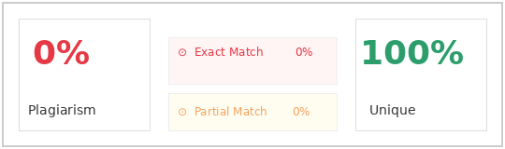
Date |  | 06/03/2026

